

# HACETTEPE UNIVERSITY

**Computer Engineering**

**BBM384 Software Engineering Laboratory**

**Sports Center Management System Change Management Report**

|  |  |
| --- | --- |
| EGE UÇAK | 21527467 |
| BAHADIR ADAK | 21526619 |
| EYÜP CAN BODUR | 21526753 |
| SERHAT SAĞLIK | 21527285 |
| BERK CAN ÖZEN | 21485591 |

<PepeFit>, 2018 Page 1

## Purpose

**Sports Center Management System Configuration/Change Management Report**

The purpose of this document is to provide a better view of how we are going to handle the changes we are going to make on the PepeFit Project.

## Introduction

The only change in software development is change. From the original concept to the completion stages, up to maintenance updates, a software product is constantly changing. Software change management is the process of choosing which changes will be encouraged, permitted and avoided based on project criteria such as timing and cost. The process determines the origins of changes, identifies critical project decision points, and identifies project roles and responsibilities.

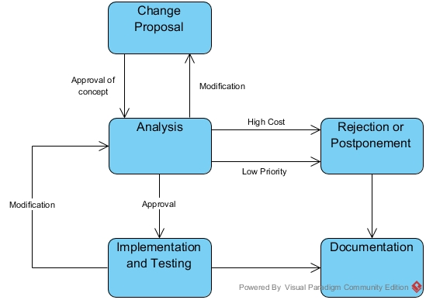

<PepeFit>, 2018 Page 2

## Our Configuration / Change Management

Change is inevitable at all stages of a software project We have experienced a process through software change management that determines which changes we should allow and prevent based on project criteria such as timing and cost. In this Process, we identified the origins of the changes, identified critical project decision points, and identified project roles and responsibilities.

We did not feel the need to update the maintenance from the original concept until the completion stages and did not encounter a possible problem. However, in this process we have made improvements for ease of use, ability to meet software requirements, and a smooth interface.

Using the GitHub project management system, we are keeping track of the changes in the project files and file systems that we are in the process of building. We provided version management.

GitHub maintains project and documentation source code. GitHub improved maintainability of the source code and reduced risk and liability. By providing such things it reduced the cost of processes in general.

In our project, our software architecture will design the software architecture and the person who will write the code will start coding according to this architecture. After writing the code, we will examine and test the results. If we do not get an error, we decide whether our code standards are appropriate, and if we agree on the architecture, we approve the code.For more code re-usability and modularity, we chose our architecture as MVC, and on this one we were saved from going through huge changes in the architecture.

<PepeFit>, 2018 Page 3

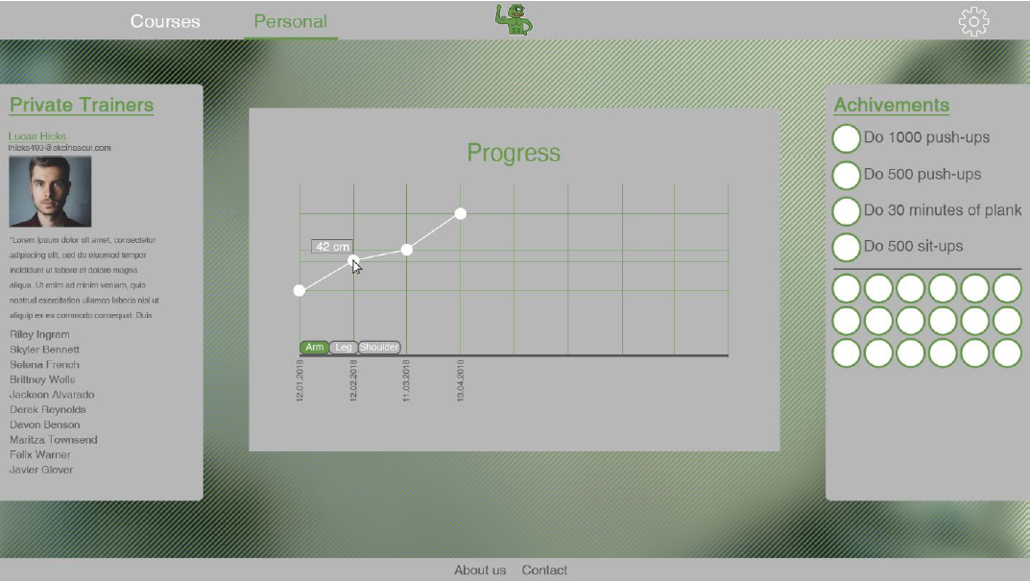 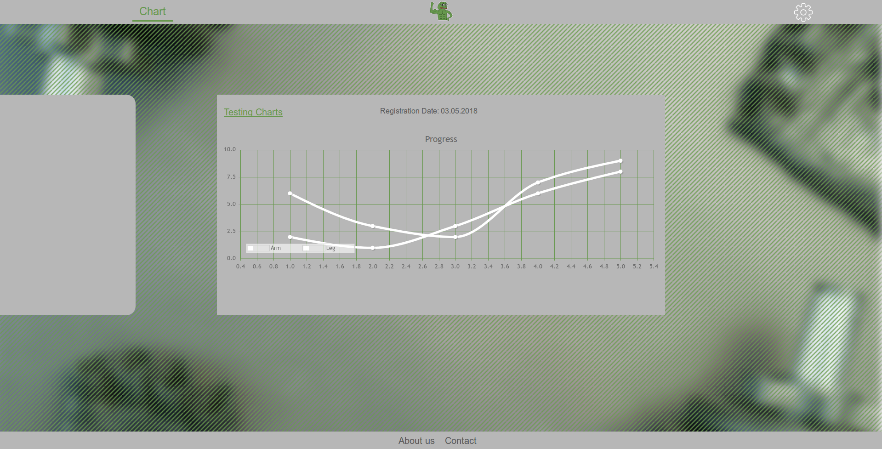

In the previous stage, the interface we created on the left side changed to the right interface, which is better in terms of both usage and design. By removing a button that is not demanded directly, we avoid unnecessary project source consumption and reduce the risk of downstream errors.

As we approached the end of the process, there were more visual changes. Some improvements between the old demo and the new demo. We made changes that appeal to the user more visually.

<PepeFit>, 2018 Page 4

## In this process we will go for possible problems with software changes;

Later on in this assignment, we can make joints and attachments depending on the user's requirements and the technology of the time. The interface designs we show may change. A more comprehensive and beautiful looking interface can be designed and added. Updates can be made on menus we have created. As project group, we described the tasks in the first part. There were no changes in the duties of the group members.

## Possible change in future;

Maybe if the number of member in our application is too much and need more detail in the future, we can make a change in the codes .

## Configuration

We followed a standard cycle of change in the changes we made in this process:

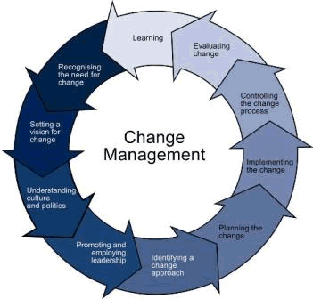

<PepeFit>, 2018 Page 5